Please use this Google doc during your interview (your interviewer will see what you write here). To free your hands for typing, we recommend using a headset or speakerphone.

There is a lot of static on my end, can you type the question? Thanks :)

I thought you had a question for me, sorry, no worries if you don’t.

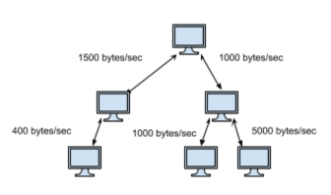

Given a root node, and a filesize of N bytes, calculate the time to transmit the file from the root node to the whole network.

class Edge:

def __init__(self, node, rate):

self.node = node

self.rate = rate

class Node:

def __init__(self, id):

self.id = id

self.edges = []

def add(self, new_id, rate):

new_edge = Edge(Node(new_id), rate)

self.edges.append(new_edge)

return new_edge.node

root = Node(‘a’)

b = root.add(‘b’,1500)

c = root.add(‘c’,1000) etc.

# 10000.0

def transmit_time(node, file_size):

stack_computer = []

stack_receive = [] # receiving rate of current computer

stack_time = []

visited = set() # the id of the computers visited

max_time = 0

# if there’s not computer

if node is None:

return 0

stack_receive.push(float(‘inf’))

stack_computer.push(node)

stack_time.push(0)

while stack_computer:

cur_receive_rate = stack_receive.pop()

cur_computer = stack_computer.pop()

cur_time = stack_time.pop()

visited.add(cur_computer.id)

for edge in cur_computer.edges:

if edge.node.id not in visited:

# calculate time

time = file_size / edge.rate

stack_computer.push(edge.node)

if cur_receive_rate == float(‘inf’):

time = 0

else:

time = file_size / (max(cur_receive_rate,edge.rate))

stack_time.push(time + cur_time)

stack_receive.push(edge.rate)

max_time = max(max_time,time+cur_time)

return max_time

Hi:)